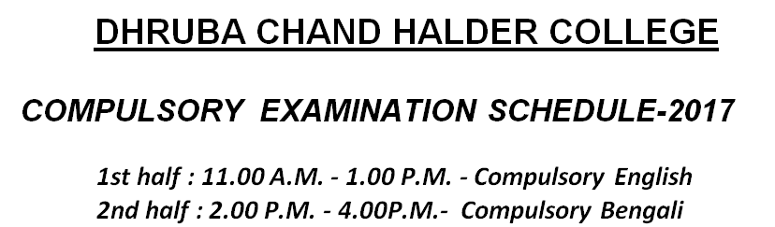

DATE | CANDIDATES
28.02.2017  ( Tuesday) | All B.Com Regular & Casual Students  ( Male & Female)
03.03.2017  ( Friday) | All Female Candidates of B.A. General  and  All Female Candidates of B.Sc.  ( Hons.+ General)
04.03.2017  ( Saturday) | All Male Candidates of B.A. General
06.03.2017  ( Monday) | All B.A. (HONS.) Students  ( Male & Female)  and  All B.Sc. Male Students  ( Hons.+ General)  and  All Casual students of B.A. & B.Sc.

- All candidates are requested to collect their provisional Admit Card from the College Office.

- Candidates without their provisional Admit Cards shall not be allowed to sit for Compulsory Examinations.

